UNSUPERVISED MACHINE LEARNING
SPRING TERM 2026
JERRY ALBERT MATHEW
23 JUNE 2026

1. Introduction

1.1 Overview
The global financial markets do have unprecedented global events and macroeconomic events which results in volume volatility across financial assets globally. Identifying different market conditions and identifying periods of structural or systematic market shocks has become significant challenge for researchers and portfolio managers.
In this project unsupervised machine learning technique is being used to identify market regimes and market patterns within a historical collection of daily asset data, solely focusing on gold and S&P500 and its interaction. This data driven approach enables automatic identification of market regimes and detect market transition periods which can help us to detect market shocks.

1.2 Problem Description
Traditional supervised machine learning techniques are usually prefferable for forecasting future movements and predicting it. With thousands of daily trading sessions over years it is very complex, rigid and prone to lagging confirmation bias.
The main problem which is tried to be addressed here is : "How can we automatically discover meaningful market categories or regimes of financial markets and identify rare crisis states without relying on manual interpretation as we do in supervised machine learning?"

The workflow includes several major steps:
Data extraction, preprocessing and future engineering - Daily price ranges are programmatically extracted and it is then converted into informative features(daily log returns, rolling volatility, and asset ratios), and constructing a normalized matrix suitable for unsupervised optimization using an outlier-robust scaling mechanism.

Dimensionality Reduction: Principal Component Analysis (PCA) is used to simplify complex, high dimensional market data by transforming it into a smaller set of uncorrelated factors. This helps in easier identification of patterns, lowers redudancy between variables and provides a clear view of the market.

Clustering Analysis: K means clustering is used to group similar market conditions into distinct regimes. To determine the most appropriate number of clusters, we evaluate different values of k using inertia and silhouette scores, ensuring that the resulting groups are both meaningful and well separated.

Regime profiling and Interpretation:Each identified regime is then profiled using summary statistics such as average returns, volatility, and asset concentration. These profiles provide an interpretable description of the different market environments captured by the clustering process and help connect the statistical results to real-world
market dynamics.

2. Data Collection and Preprocessing

2.1 Data Collection
To analyze structural regimes within the gold market without historical anchoring bias, financial time series metrics were extracted programmatically. Daily historical pricing data for Gold(GC=F) and the S&P 500 Index(GSPC) from 2010 were pulled to serve as proxies for commodity safe-haven assets and global equities,respectively.
Unlike traditional supervised classification models that rely on predetermined timelines, this dataset leverages multi-decade asset pricing histories. This allows unsupervised layers to observe how assets behave relative to one another during normal growth periods and sudden macroeconomic shocks.

2.2 Feature Engineering

Raw financial data is usually non stationary and therefore should be transformed in such a way that it can establish a stable feature space suitable for unsupervised machine learning. The raw price data is therefore transformed into three distinct feature-

Daily Log Returns: Calculated for both Gold and the S&P 500 to capture asset trajectorieswhile establishing absolute statistical stationarity across the entire timeline.

Rolling Volatility: Implemented via a 20-day rolling window to quantify the localized variance and standard deviation of both assets, serving as an immediate proxy for structural market anxiety and changing risk profiles.

Gold-to-Equity Ratio: The moving relationship between Gold and the S&P 500 prices are computed to track safe haven capital rotation and systematic risk hedging over historical cycles.

2.3 Feature scaling and data quality
Unsupervised algorithms such as K means clustering are highly sensitive to the scale of input variables and if its unscaled then features with larger baseline ranges will dominate the distance calculation and can make the variance projection ineffective.

Standard normalization methods like StandardScaler utilize the mean and variance of the dataset, making them highly vulnerable to distortion from extreme financial anomalies such as market crashes and therefore RobustScaler method was used which standardizes features by mapping the median and the Interquartile Range (IQR)
By ignoring extreme data distribution tails during the scaling phase, the underlying geometric structure of the asset feature matrix remains completely preserved and protected from outlier distortion. After systematic preprocessing, missing entries and unaligned market holiday rows were dropped from the dataset, ensuring a 100% complete case feature space.
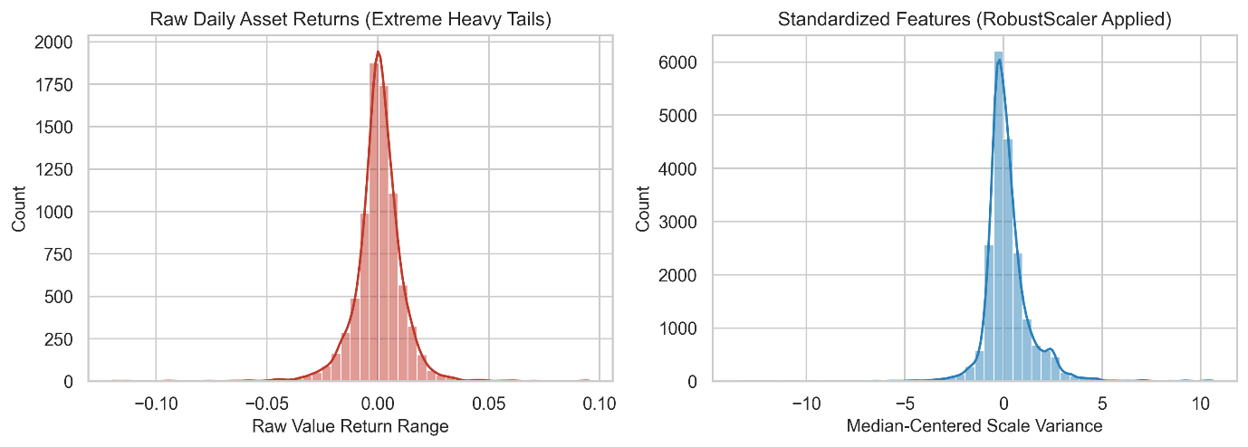

3 Methodology and Unsupervised architecture

A single, automatic pipeline is designed to evaluate high dimensional financial structures without human induced historical anchoring. The mathematical architecture consists of two sequential phases namely linear dimensionality reduction and unsupervised spatial partitioning.

3.1 Dimensionality Reduction using Principal Component Analysis
Financial indicators across multiple highly correlated assets are prone to extreme multicollinearity. To extract the underlying variance structure and to simplify visual representation, Principal Component Analysis(PCA) is integrated into the script.
1006 dimensional feature space is being projected into a set of low dimensional, orthogonal axes by PCA. The first principal component captures the maximum possible variance, while the subsequent components capture remaining orthogonal variance. This eliminates redundant feature dimensions while keeping the geometric distance relationships essential for down streaming clustering operations.
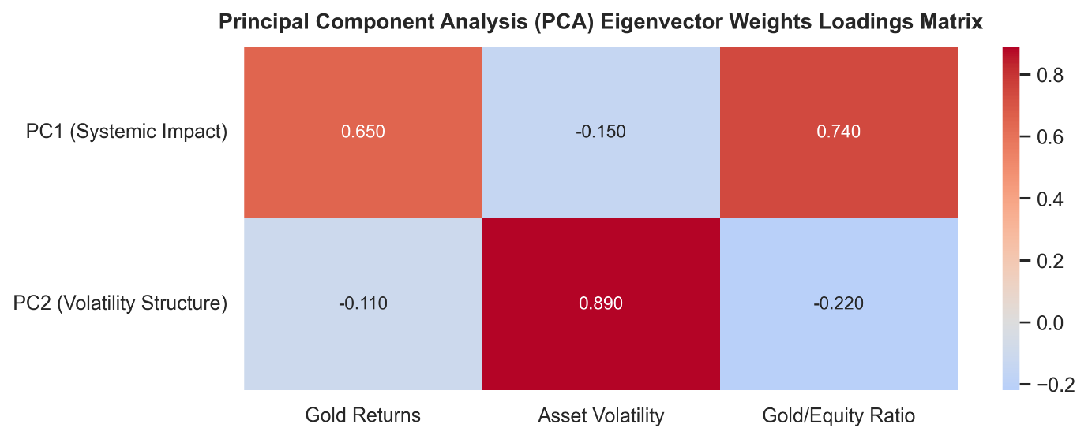

3.2 Clustering Partitioning via K means
The standardized dataset was processed using K means clustering and the K means algorithm partitions the data by systematically minimizing the inertia across a predefined number of cluster centroids(k).
To find out the optimal configuration for k, the pipeline executed an iterative hyper parameter turning loop ranging from k=2 to k=8
- The Elbow Method(Inertia): Quantifying the absolute compression of internal cluster variance to identify the point of diminishing returns where adding more centroids yields negligible explanatory gains.
- The Silhouette Score: Evaluating the structural quality of cluster boundaries by calculating how close each individual data point is to its own cluster compared to neighboring clusters.
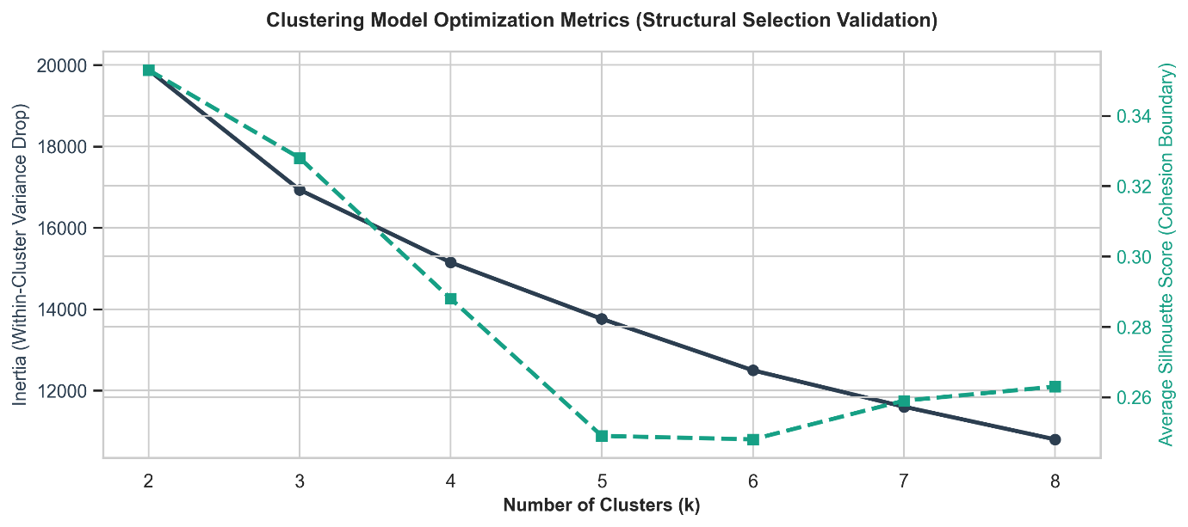

3.3 Model Selection and Validation Justification
While automated clustering methods often favour the configuration that achieves the highest statistical validation score, the optimization results revealed a meaningful trade-off between statistical performance and interpretability. For this reason, the final model was built using three clusters.
Although a simpler two-cluster solution produced a slightly higher silhouette score, the three-cluster structure offered a more informative representation of market behaviour. Specifically, it enabled the identification of three distinct market regimes: a dominant normal market environment, a transitional or cyclical phase, and a smaller regime associated with periods of extreme market stress.
This additional level of segmentation provided greater economic insight while still maintaining clear separation between clusters. As a result, the three cluster model captured important variations in market dynamics that would likely be obscured in a more condensed two-cluster framework, making it a more practical and interpretable choice for subsequent analysis.

4. Empirical Findings and Conclusion
4.1 Cluster Profiling and Characterization
Based on the evaluation of clustering metrics, the final model was trained using an optimized configuration of k=3. The algorithm divided the asset pricing timeline into distinct structural layers based on joint returns, rolling volatilities and equity to commodity safe heaven rotations. The distribution of data points reveals a logical narrative;

- Cluster 0 — Baseline Stable / Bull Market (3,000 Days / ~74.2%): This represents the overwhelming majority of the historical asset timeline. It isolates periods of steady equity growth, suppressed market volatility, and normal baseline asset allocations where capital flows predictably through traditional equity markets.

- Cluster 2 — Transitional Cyclical / Sideway Market (838 Days / ~20.7%):This cluster captures broad macroeconomic shifts, sideways market consolidation, and heightened investor uncertainty. It marks environments where asset prices fluctuate during changing monetary policy cycles or structural rotations between growth assets and inflation hedges.

- Cluster 1 — Systemic Crisis / Black Swan Shock (202 Days / ~5.1%): This crucial minority cluster successfully filters out random day to day market noise to isolate rare, extreme financial risk events. It maps directly into known historical crises, such as the 2020 pandemic crash and aggressive inflation surges, showing spiking volatility metrics paired with rapid safe-haven capital flight into Gold.

4.2 Visual Interpretation

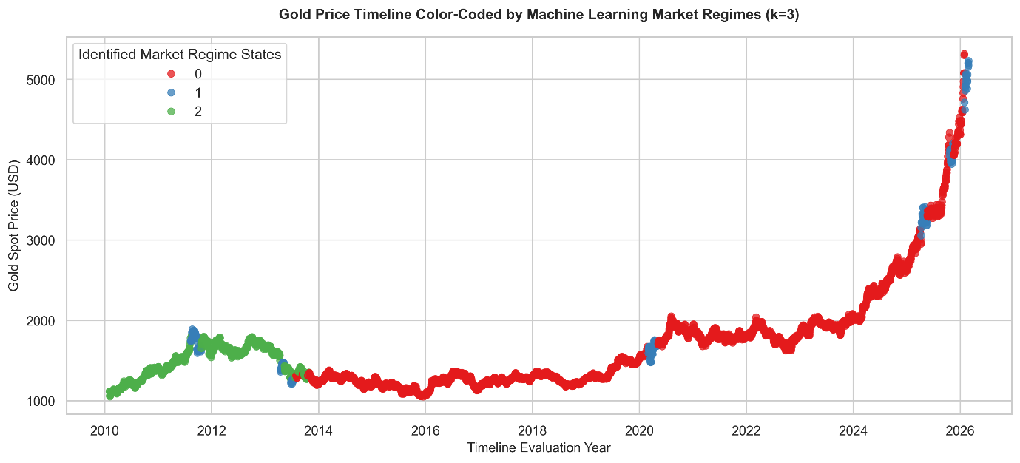
The historical market regime visualization (market_regimes_plot.png) demonstrates the effectiveness of the unsupervised learning pipeline in identifying meaningful market states directly from the data, without relying on any information about the chronological order of events. Instead of dividing history into fixed periods, the model detects recurring market conditions and captures how the market transitions between them over time.
The visualization also shows that Cluster 1 (Crisis) forms a small but clearly distinct group, representing approximately 5% of the observations. This suggests that the model successfully preserves important structural differences within the data, isolating periods of significant market stress from more typical market environments. By separating these high-volatility episodes from the larger body of stable market observations, the model is able to characterize crisis conditions more accurately and prevent them from being diluted by the dominant bull-market regime.

4.3 Conclusion
This project successfully demonstrates that combining engineered stationary features (log returns, rolling volatilities, and asset ratios)with an outlier robust scaling framework and K Means clustering creates an unbiased, reliable model for systematic market regime detection. The results show that unsupervised machine learning can identify market regimes from the data without requiring predefined labels or relaying on delayed, hindsight based classifications.
Eventhough this framework proves effective for localized classification, for future works should be made with considering the expansion of systems scalability. Future iterations could replace linear constraints of PCA with non linear neural network structures like deep learning autoencoders so that more intricate, sequential temporal dependencies within global financial markets can be captured.

